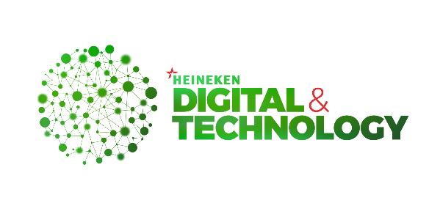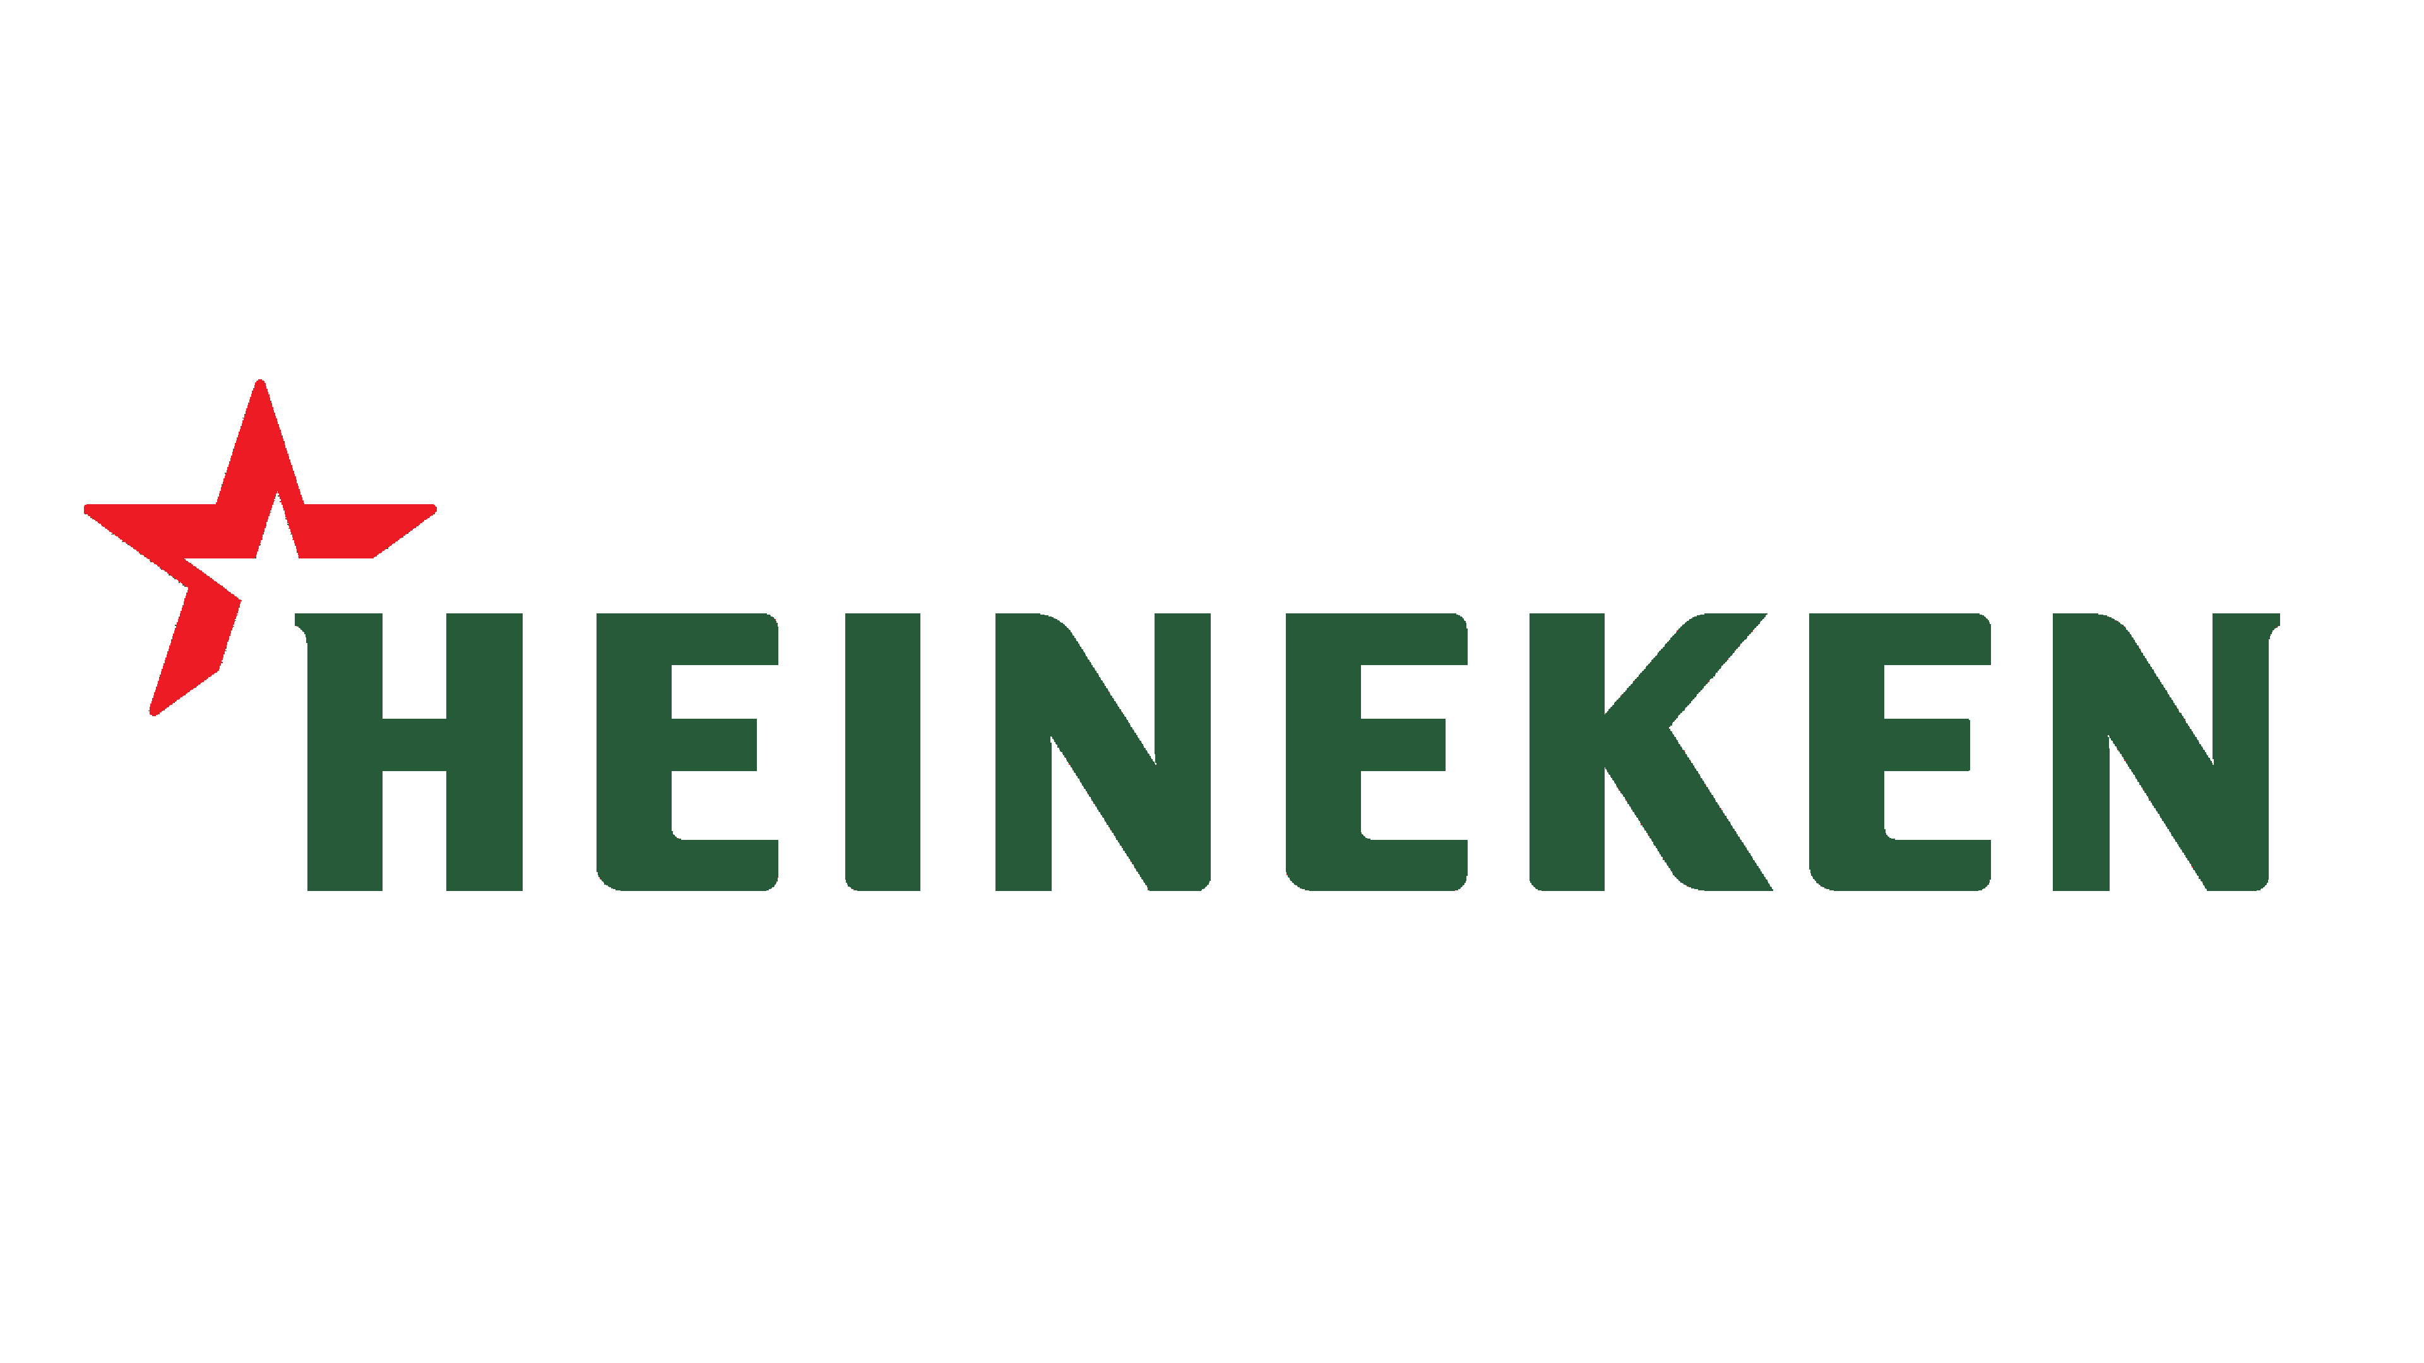

**Project Proposal**

**HEINEKEN Cambodia**

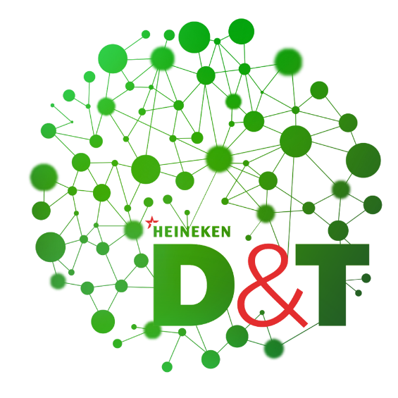

**TPO & Customer Targeting**

**Recommendation**

**Student: Votana SREY, 6th Generation**

**Supervisor: Kanika MONTHA**

**Advisor: Chanto TENG**

**Team: Data & Analytics, D&T**

**Date: 9th January 2023**

1. **Project Introduction**

Trade Program/Promotion plays an important role in a variety of industries such as food delivery, banking, transportation, consumer electronics and beverage. Over time, the products that customers are attracted to can change. In general, the trade has often been set by mass marketing and celebrity culture. Increasingly, customers are not only keeping up with this general trend, but also with trends in their own social circles. We need to measure these trade program performance effects before we can target the right customer and target promotions effectively. In this work, our goal is to have the right target customer to sell our promotion/program and use them to improve demand estimation and devise promotion targeting. The process by which customers affect each other is complex.

We are specifically interested in estimating the causal effect that one customer’s purchase has on another customer’s purchase decision. This is a difficult problem, because a purchase not only depends on trade, but can also be caused by factors such as an item’s pricing or a time period’s seasonality. In this work, we aim to combine both the estimation of the target customer graph and the optimization of targeted promotions over the graph. For this purpose, we need to ensure that the target customer can be optimized over. Therefore, we construct the target customer recommendation model that can be represented by an interpretable graph model describing by how much one customer’s purchase increases the probability of another customer’s purchase.

1. **Objective**

The customer Trade Program Targeting Recommendation has the object to support the trade marketing to do the program to the right customers and effective, Moreover, we would:

* Improve the trade program targeting effectively
* Increase the sell volume of customers & program performance as well
* Understand the customer’s behaviors & performance
* Improve the master data and data model & what the need to push master data help the trade program targeting.

Trade Marketing Team is currently quite well doing on the customer program targeting but the problem is we don’t have the standard recommendation to them to improve the trade program targeting and optimization as well. Thus Data & Analytic Team has come up an idea to assist TM to solve this out to increase the sell volume and company KPI as well.

**Academic/Practical Relevance**: From an academic point of view, we want to develop the model to detect the customer targeting effect solely from transactional data and optimal program targeting as well.

1. **Hypothesis**

To finetune customer targeting recommendation in order to leverage the effectiveness of the trade term program. To apply analytics model in order to uncover any hidden gaps in master data and trade term is the selected case for this study. We are currently having the hypothesis to test it out:

* Null Hypothesis (H0): Improving the trade program and customer targeting will not effect to the sale volume of the trade program performance target.
* Alternative Hypothesis (H1/HA): Improving the trade program and customer targeting will increase the sale volume 10% of the trade program performance target.

Think more, only one volume but think about the profit and revenue as well.

(Check the TMK to make more specific and deeper into the hypothesis) – check current type of program targeting. How many types?

No statistical hypothesis (remove 10%)

**Research Questions:**

* Questions to the current process???
* What are the other possible customer targeting methods/model we should consider?​
* What are the other customer information we should collect and maintain in master data in order to support the targeting strategy? ​
* The market is moving toward premium and digitalization, how can master data be maintained differently to accommodate this change fast and support in accelerating speed to the market? ​ How can master data maintain to support the trade program targeting?
* Which models are widely studied for conducting customer targeting recommendation? Specific and detail on into the model. What model is the best performance?
* What are the most widely used evaluation metrics to evaluate the performance of customer targeting recommendation machine learning models? (remove it?) ​

1. **Methodology**

**Exploratory Data Analysis:** In this part, we are going to extract the data from the data warehouse of outlet transaction data to see the performance and we are going to explore the data in order to gain more insights from the data and also the trade marketing insight analysis as well. We would like to explore on:

* Trade Program Performance Analysis
* Customer Performance Analysis & Segmentation Exploratory

**Advance Analytic:** In this part, we would like to deeper dive into the solution to deal with trade marketing of customer trade program targeting recommendation to the right customers as well. It will be more insightful for the TM and company either.

Historical Customer Data

Trend-Estimation Algorithm

Adaptive-Greedy Algorithm

Customer Performance (Volume, Market Share, Satisfaction)

Promotion Price and Budget

1. **Project Planning**

The training has the 4 months in duration. That’s started from 15 January 2023 to 15 May 2023. This table below illustrate the training planning and listing the tasks to finish the project.

|  |  |  |  |  |  |  |  |  |  |  |  |  |  |  |  |  |
| --- | --- | --- | --- | --- | --- | --- | --- | --- | --- | --- | --- | --- | --- | --- | --- | --- |
| **Task** | **Week** | | | | | | | | | | | | | | | |
| **1** | **2** | **3** | **4** | **5** | **6** | **7** | **8** | **9** | **10** | **11** | **12** | **13** | **14** | **15** | **16** |
| Understand Business Pain Point |  |  |  |  |  |  |  |  |  |  |  |  |  |  |  |  |
| Align with the Stakeholders |  |  |  |  |  |  |  |  |  |  |  |  |  |  |  |  |
| Install an Environment |  |  |  |  |  |  |  |  |  |  |  |  |  |  |  |  |
| Data Collection |  |  |  |  |  |  |  |  |  |  |  |  |  |  |  |  |
| Data Cleansing |  |  |  |  |  |  |  |  |  |  |  |  |  |  |  |  |
| Exploratory Data Analysis |  |  |  |  |  |  |  |  |  |  |  |  |  |  |  |  |
| Machine Learning Training |  |  |  |  |  |  |  |  |  |  |  |  |  |  |  |  |
| Machine Learning Evaluation |  |  |  |  |  |  |  |  |  |  |  |  |  |  |  |  |
| Result Validation |  |  |  |  |  |  |  |  |  |  |  |  |  |  |  |  |
| Prepare Slide & Report Thesis |  |  |  |  |  |  |  |  |  |  |  |  |  |  |  |  |

1. **Technology**

To build the project up, we have final the technology, tool, library to consolidate with it as well.

**List of Languages:**

* Python
* Structure Query Language (SQL)
* DAX

**List of Tools:**

* Microsoft SQL Server Management Studio
* Colab / Jupter Notebook / Anaconda
* Visual Studio Code
* Microsoft Power BI
* GitHub

**List of Libraries:**

* Scikit-Learn
* Pandas
* Numpy
* Matplotlib
* Seaborn
* Plotly

**VII. References**

Akhlaghpour, Hessameddin, Mohammad Ghodsi, Nima Haghpanah, Vahab S Mirrokni, Hamid Mahini, Afshin Nikzad. 2010. Optimal iterative pricing over social networks. International workshop on internet and network economics. Springer, 415–423

Lennart Baardman, Setareh Borjian Boroujeni, Tamar Cohen-Hillel, Kiran Panchamgam, Georgia Perakis, Detecting Customer Trends for Optimal Promotion Targeting

Evasaria M. Sipayung, Herastia Maharani, Benny A. Paskhadira, Designing Customer Target Recommendation System Using K-Means Clustering Method, IJITEE, Vol. 1, No. 1, March 2017